**User manual**

Sign in page of teacher and student

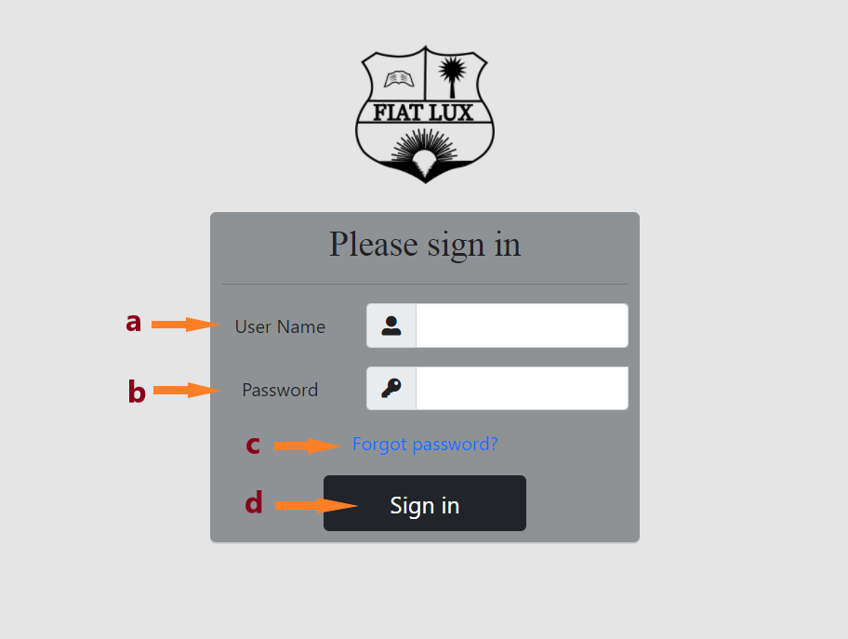

a- user name of the user should be given in this field.

b- password of the account should be given in this field.

c- By clicking this user can get help from the system if they don’t remember their password.

d- If user name and correct password is given user can log into their account.

Home page of teacher

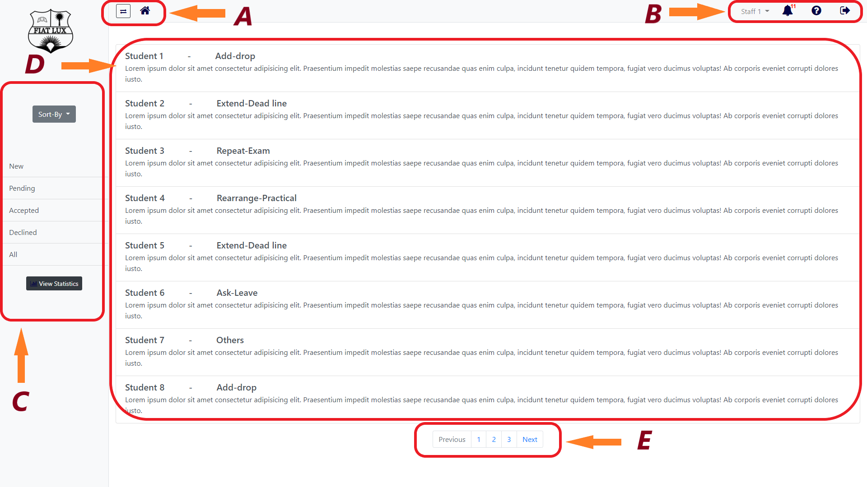

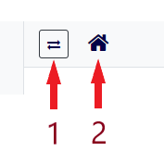

1 - To extend and hide the side bar.

2 - By clicking this home icon teacher will be directed to his/her home page.

1. 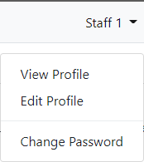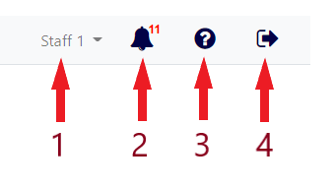
2. By clicking this icon staffs will see a drop down list as shown above where they can see their account information and settings, and edit them.

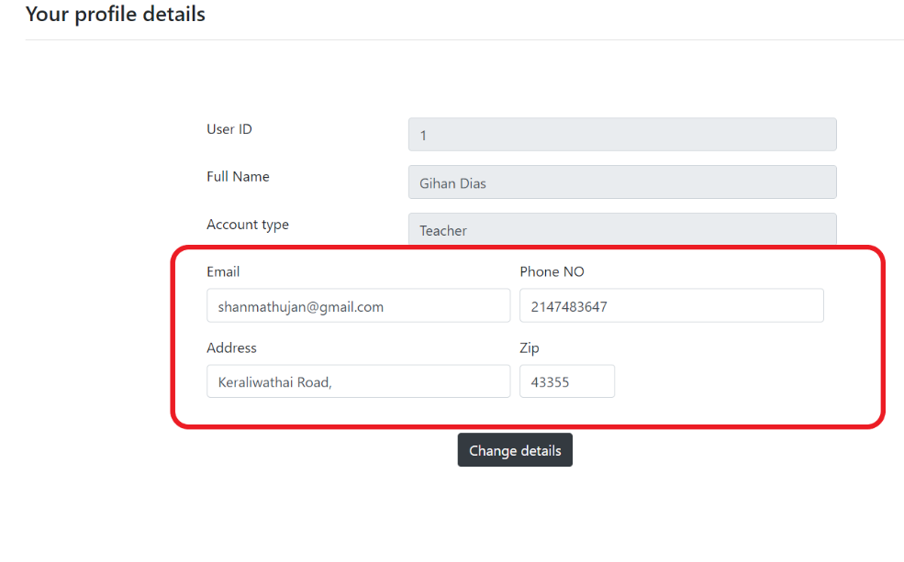

It shows user’s details.

Only user can edit details in red box.

After user edit the details, click the Change details icon to save them.

There is a separate option which directs them to the page where they can change their password.

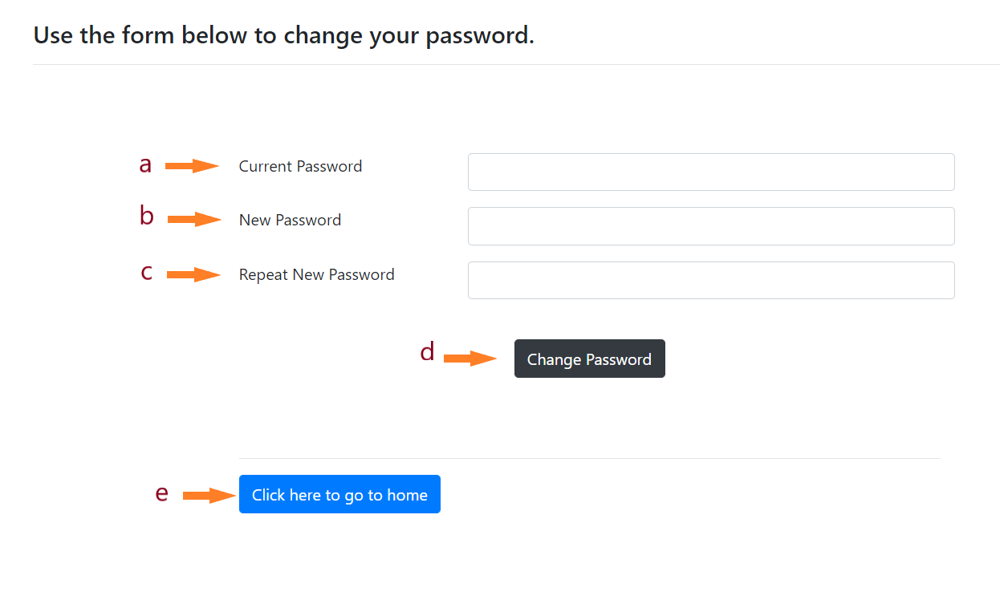  
 a- Enter the current password in given box.

b- Enter the new password in given box.

c- Again enter the new password correctly.

d- After fill given boxes, click this icon to change the password.

e- By clicking this icon user can go to home page.

1. By clicking this icon staff will see a dropdown list as shown below. The small number above the bell icon indicates the number of unread notifications.

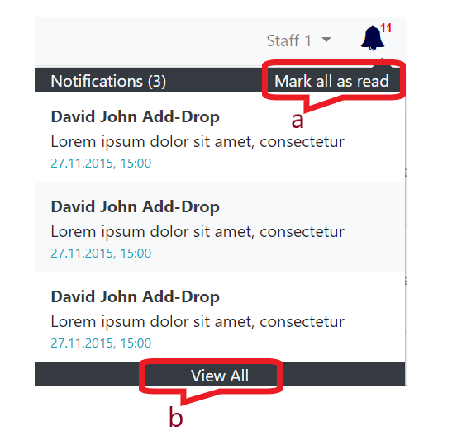

1. mark every notification as read and the small number above the bell icon disappears.
2. Staff can view all the notifications.
3. Help icon to direct staffs to the page where they can get solutions for problems.
4. Staffs will get logged out from the system.
5. 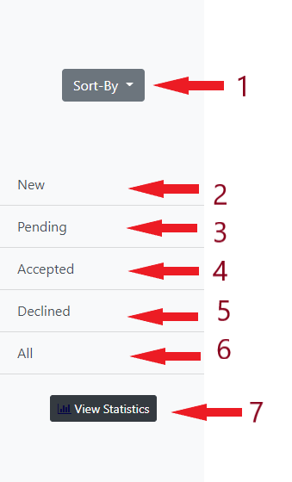

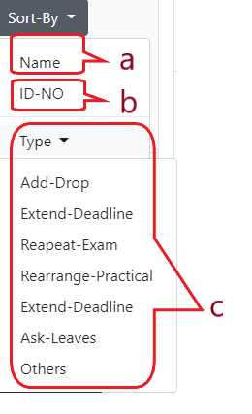

1- Staffs can sort out requests by students’ name(a) or students’ ID(b) or by the type of issues(c).

1. To view the new requests
2. To view the pending requests
3. To view the accepted requests.
4. To view the declined requests.
5. To view all requests.
6. By clicking this staffs can view the statistical representation of all the requests.
7. Shows all the requests where new requests appear first.

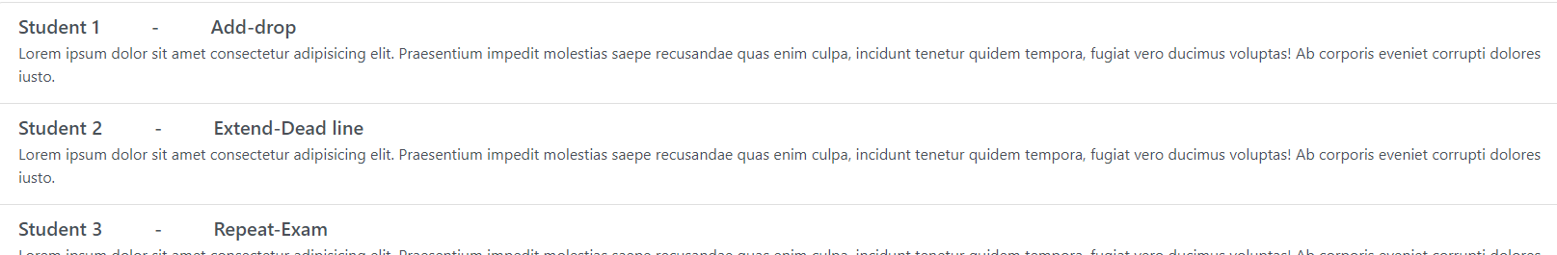

By clicking a request, user can see the details about this request.

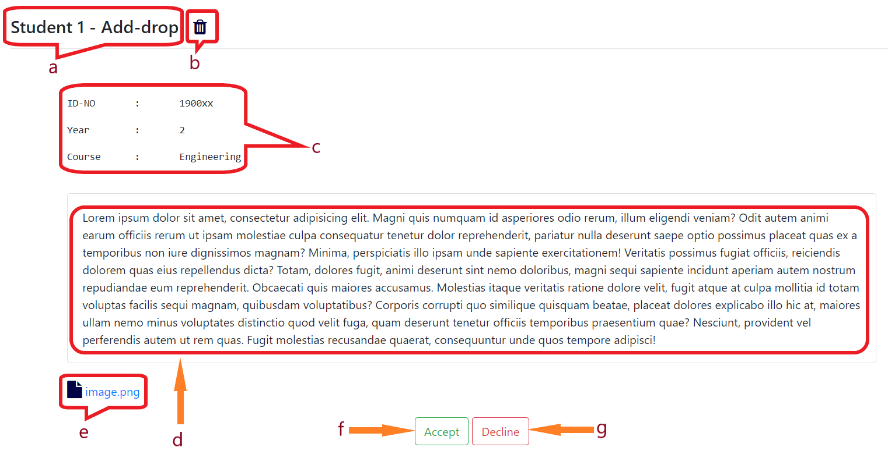

1. Shows the name of the student and the request type.
2. Button to delete the request.
3. Shows the details of the student which he/she submitted.
4. Request details and explanations submitted by the students appear in this box.
5. The evidence submitted by the student to support his/her request.
6. To accept the request.
7. To decline the request.

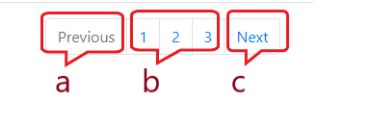

a- Can go to the very previous page.

b- Can select a specific page

c- Can go to the very next page

Home page of student

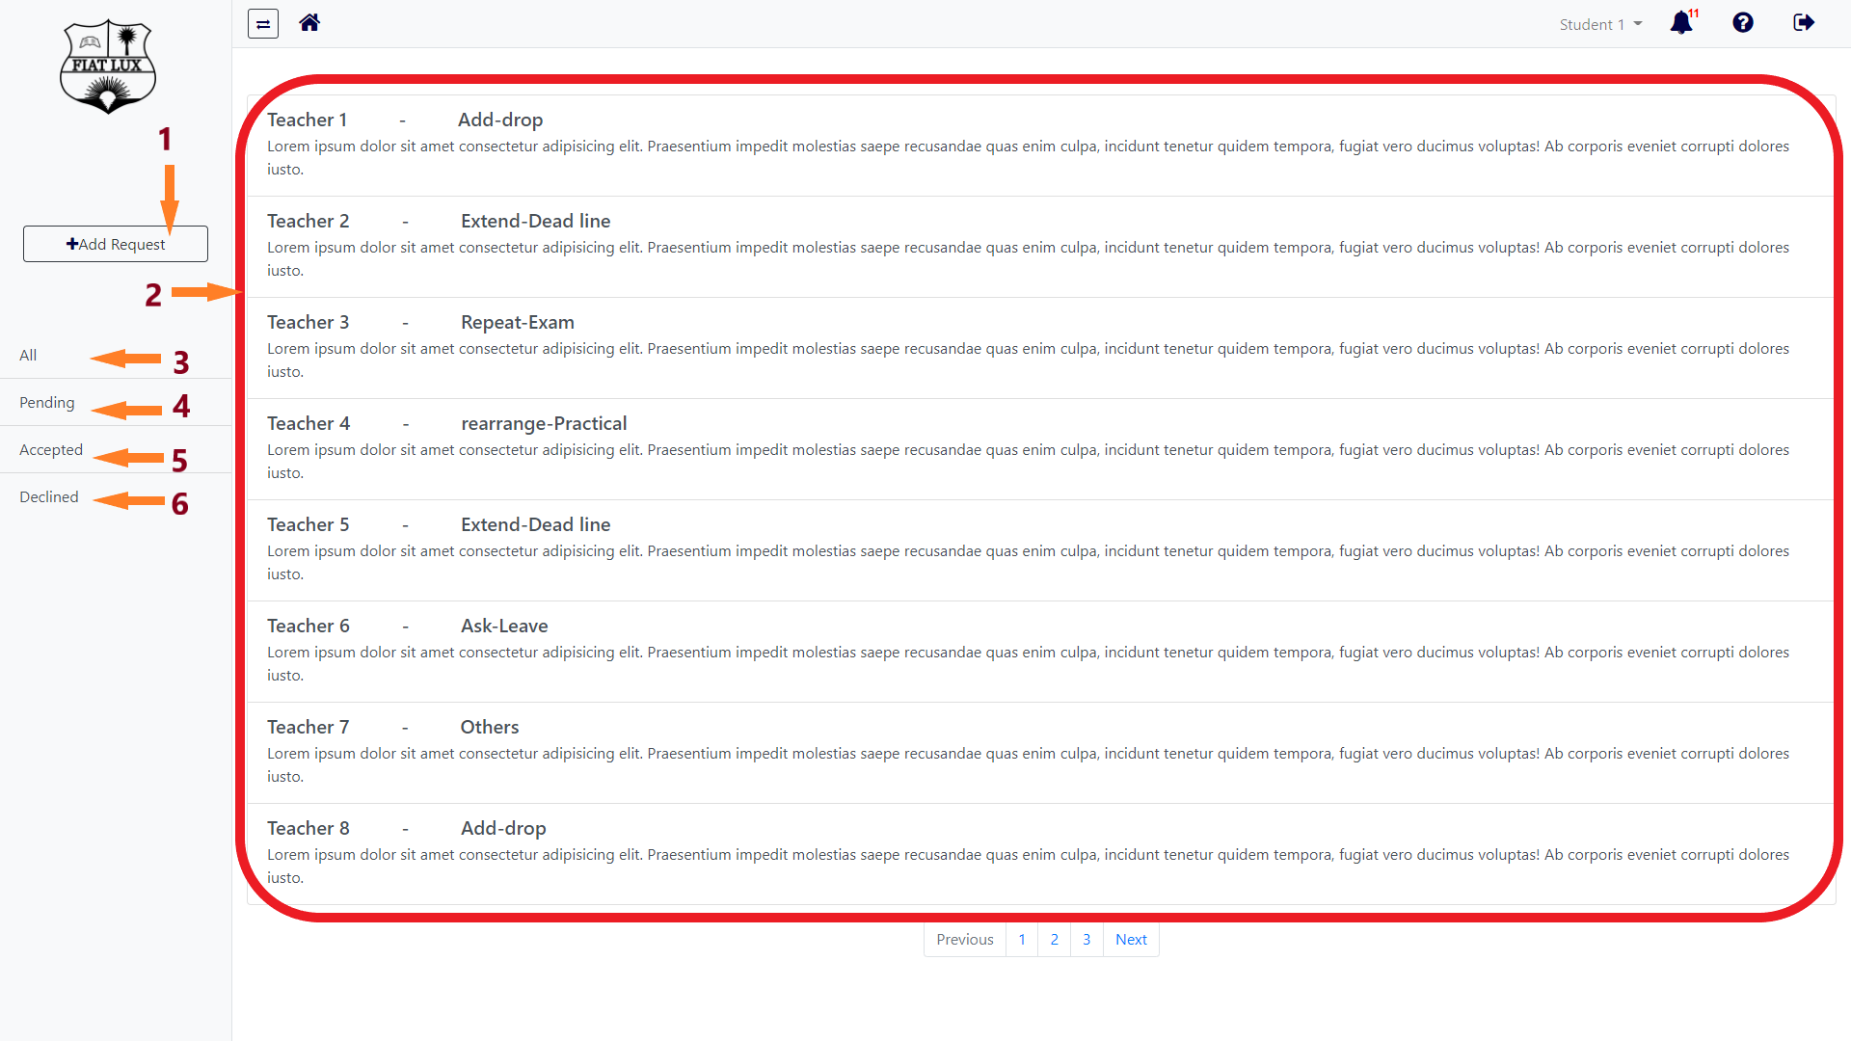

1- Students will be directed to the page to submit their request with evidence. (Add request page is given -in next page)

2- Students can view their submitted requests in the chronological order (newest to oldest). By clicking a request, user can see the details about this request.

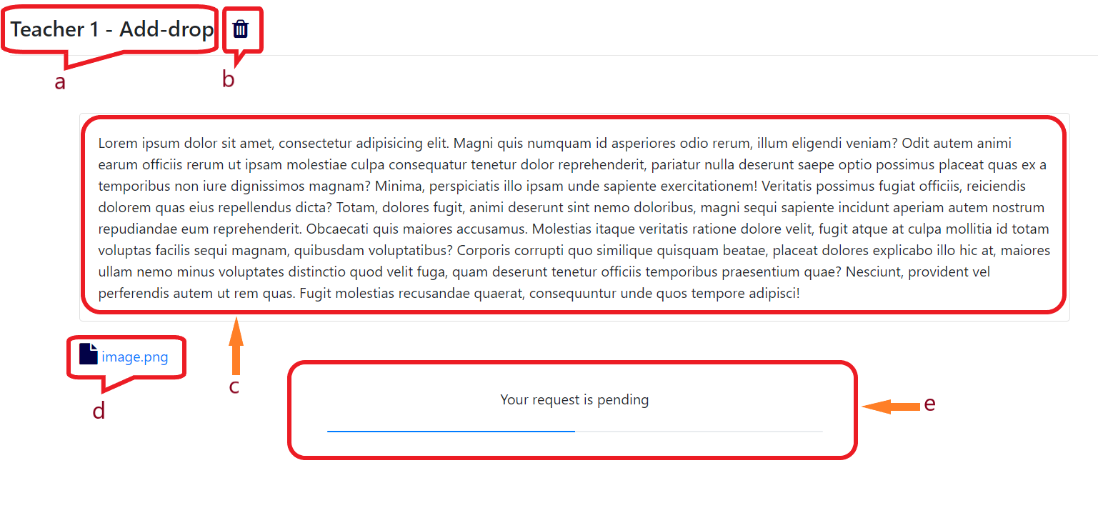

1. The submitted request type and the teacher to whom the request was made.
2. Button to delete the request.
3. Details submitted by the student.
4. The evidence submitted by the student to support his/her request.
5. Request progress bar.

3- Students can view all the requests they have submitted in the past.

4- Students can particularly view the pending requests.

5- Students can particularly view the accepted requests.

6- Students can particularly view the declined requests.

Add Request page

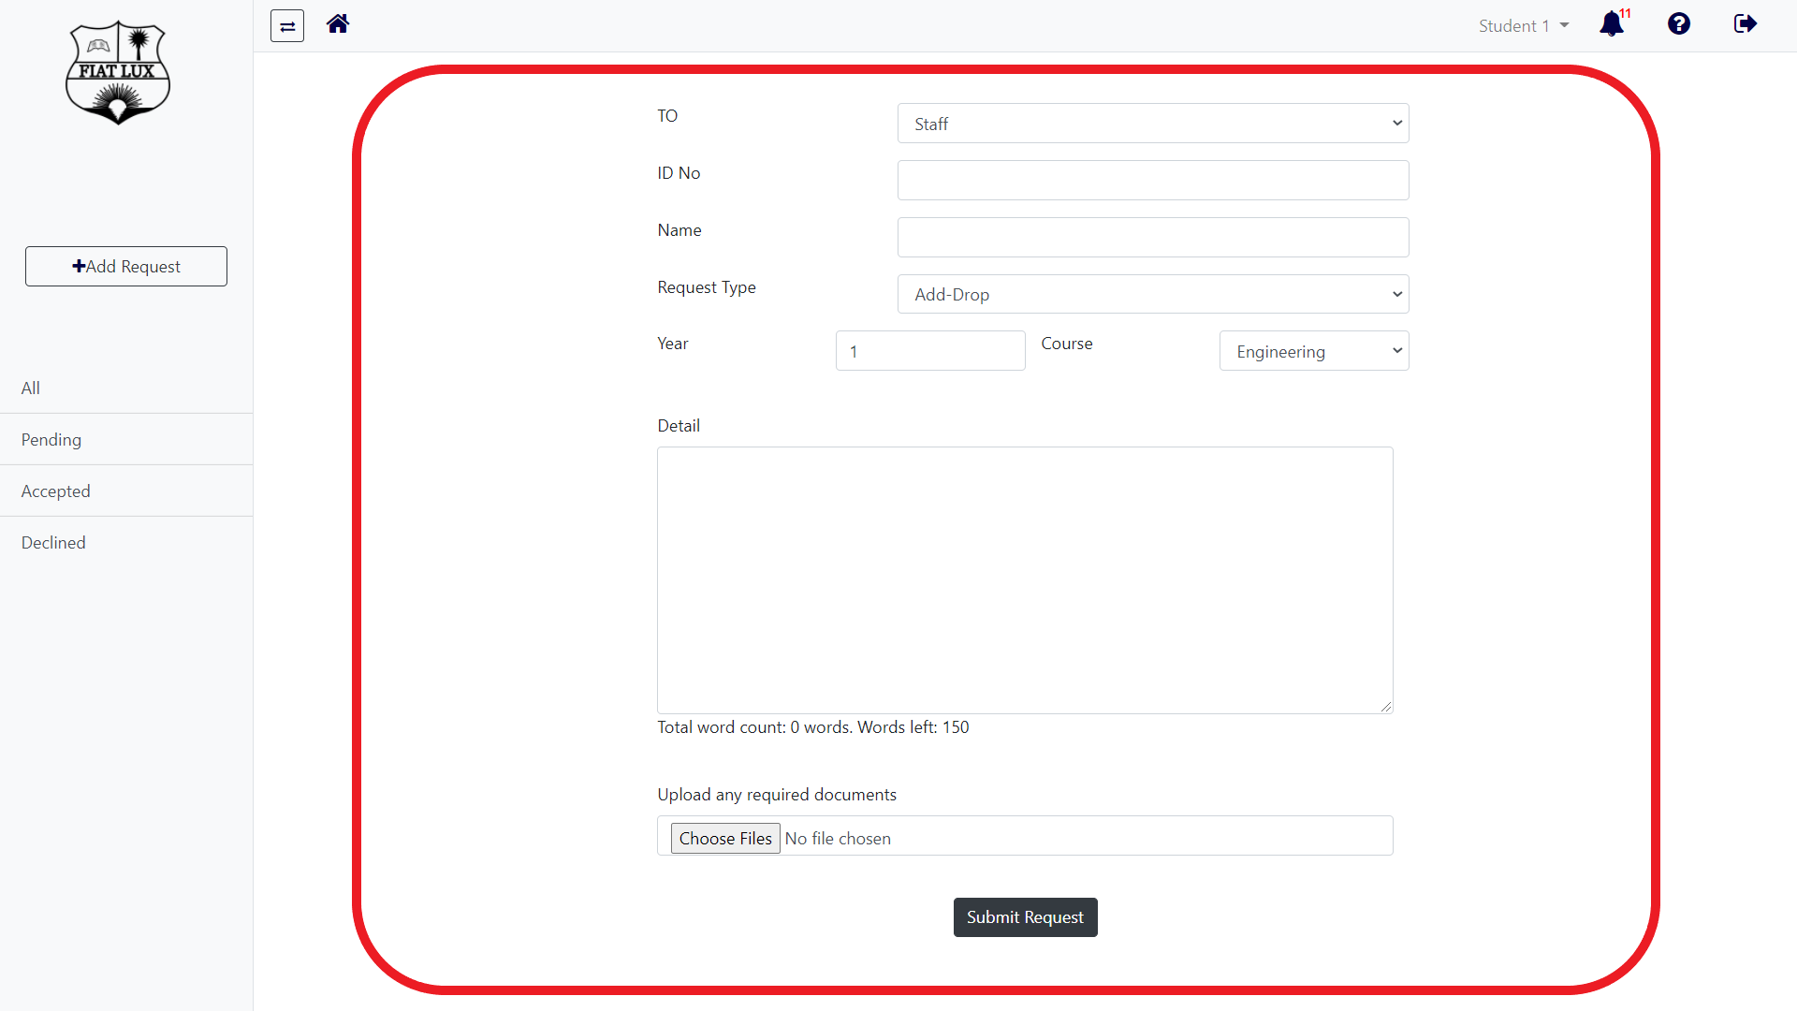

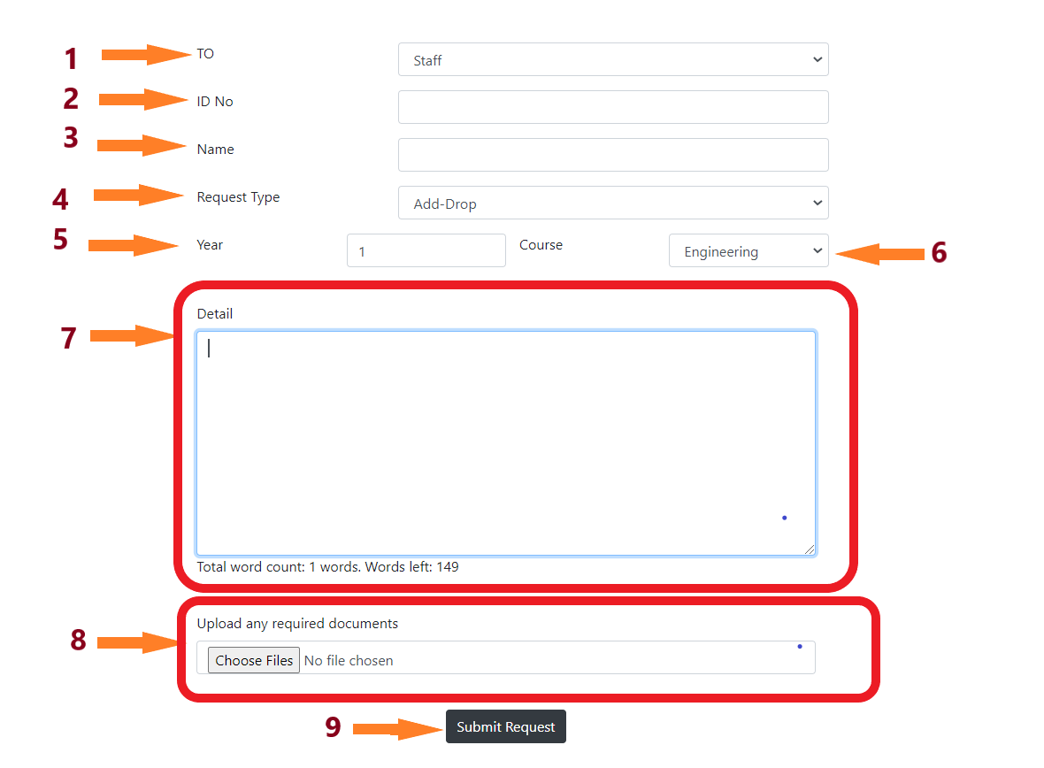

1- Students can select a staff from all the staffs in contact with him/her in the current semester, and this list will keep changing automatically each semester.

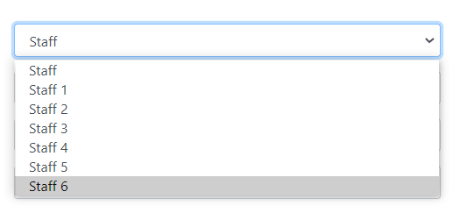

2- Students should provide their ID number in this field.

3-Students should provide their name in this field.

4- Students can select a request type from the common request types, and if it is not in the list they can simply click others option.

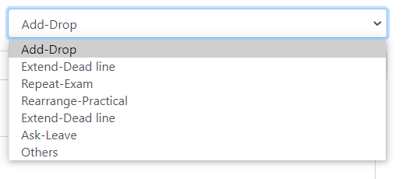

5- Students should select their year of study in this field.



6- Students should select their course in this field.

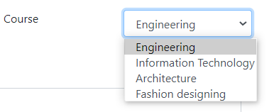

7- Students should provide the reasons and details for their request.

8- Students can provide any evidence to support their request.

9- Students can submit their request by clicking this button.